# K8S Pod Security Policy

Policies prevent users or developers from creating containers with certain configurations.

Pod security policy help in defining policies to restrict pods from being created with specific capabilities or privileges.

Enable pod security policy in admission controller

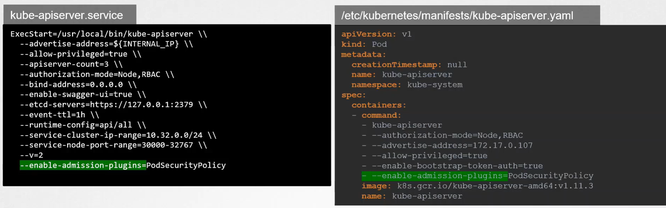

If not authorized the security policies API, the admission controller will not be able to communicate the pod security policies API and thus reject all requests, even if the requests are valid.

Therefore, it is necessary to use RBAC to grant access so that pod service account can get pod security policies can create the pod finally.

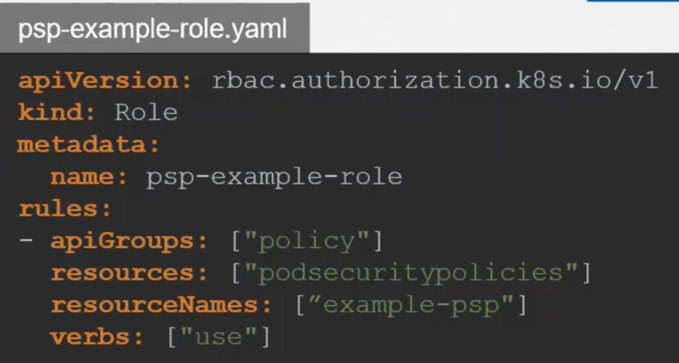

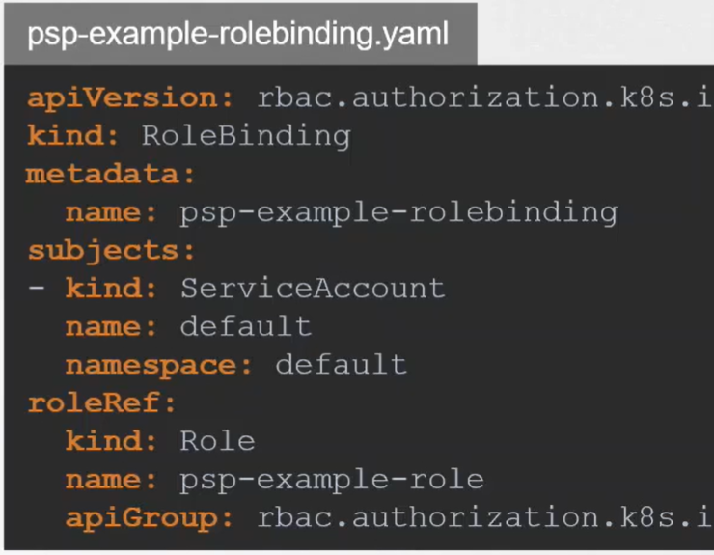

Define Pod Security Policy

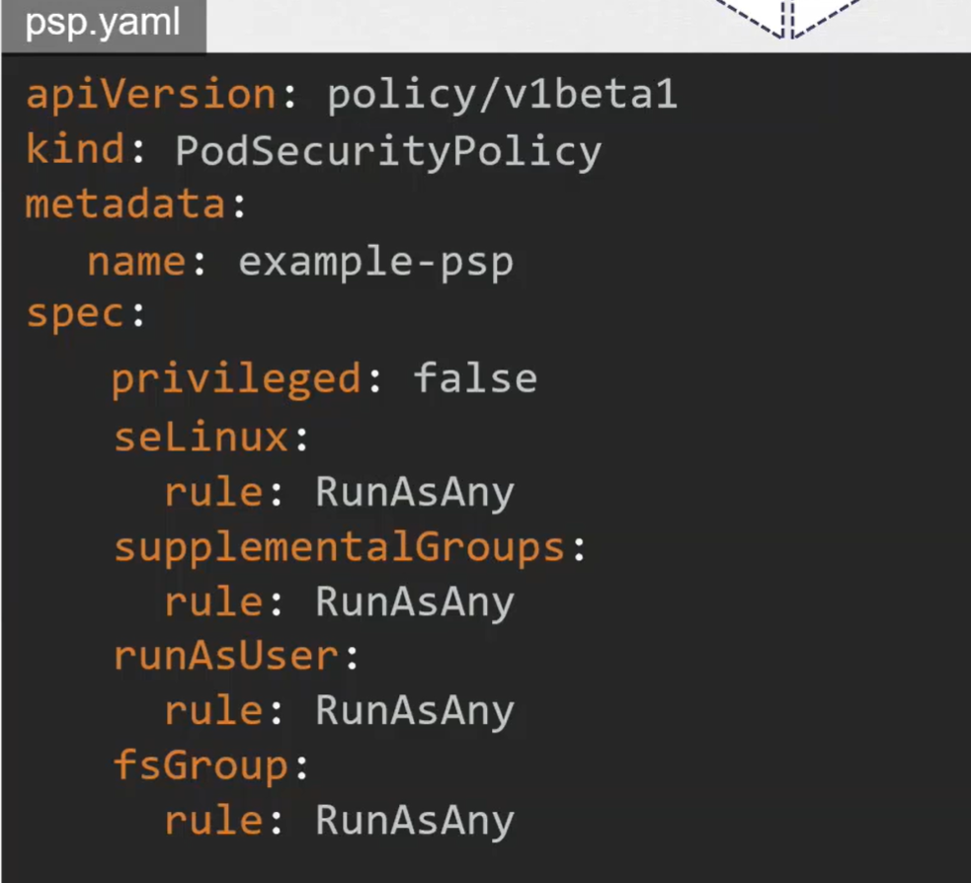

When privileged set to true, it will reject every pod creation request

